Result of the Map6_with_barrier_6

Table

Map6_with_barrier
Angle degree | Robot_size | Route distance | Running time (s) | Coverage (%)
357 | 6 | 1575,74 | 147,72 | 75,39
358 | 6 | 1635,69 | 110,73 | 76,86
359 | 6 | 1662,76 | 101,82 | 77,67
0 | 6 | 1432,45 | 52,43 | 67,37
1 | 6 | 1739,32 | 29,47 | 77,91
2 | 6 | 1816,17 | 80,5 | 79,46
3 | 6 | 1781,47 | 33,65 | 79,68
43 | 6 | 1667,77 | 34,91 | 80,62
44 | 6 | 1729,82 | 28,62 | 81,21
45 | 6 | 1637,39 | 36,81 | 81,15
46 | 6 | 1718,49 | 50,72 | 82,15
47 | 6 | 1806,97 | 31,59 | 81,19
87 | 6 | 1643,09 | 46 | 77,73
88 | 6 | 1687,38 | 78,24 | 77,47
89 | 6 | 1655,08 | 44,31 | 77,57
90 | 6 | 1602,57 | 50,69 | 75,29
91 | 6 | 1578,09 | 55,8 | 73,38
92 | 6 | 1717,93 | 52,34 | 78,06
93 | 6 | 1674,29 | 66 | 76,32
177 | 6 | 1652,81 | 53,66 | 76,35
178 | 6 | 1760,47 | 51,15 | 75,84
179 | 6 | 1702,19 | 42,75 | 76,08
180 | 6 | 1501,82 | 59,53 | 70,07
181 | 6 | 1700,91 | 29,56 | 77,6
182 | 6 | 1728,97 | 34,94 | 78,37
183 | 6 | 1807,12 | 37,93 | 79,51
223 | 6 | 1683,26 | 30,15 | 81,25
224 | 6 | 1882,85 | 29,8 | 81,05
225 | 6 | 1859,71 | 44,06 | 82,21
226 | 6 | 1762,28 | 26,08 | 81,41
227 | 6 | 1702,45 | 24,99 | 81,8
228 | 6 | 1843,57 | 26,83 | 81,6
267 | 6 | 1682,82 | 41,99 | 77,49
268 | 6 | 1722,52 | 41,04 | 77,52
269 | 6 | 1703,14 | 40,03 | 77,32
270 | 6 | 1702,12 | 94,66 | 78
271 | 6 | 1591,95 | 49,12 | 72,56
272 | 6 | 1761,44 | 85,59 | 76,9
273 | 6 | 1772,99 | 149,06 | 77,14

Blue color is the best result.
Red color is the best Horizontal/Vertical.
Green color is the Best approximate vertical/horizontal angle degrees.

Best result
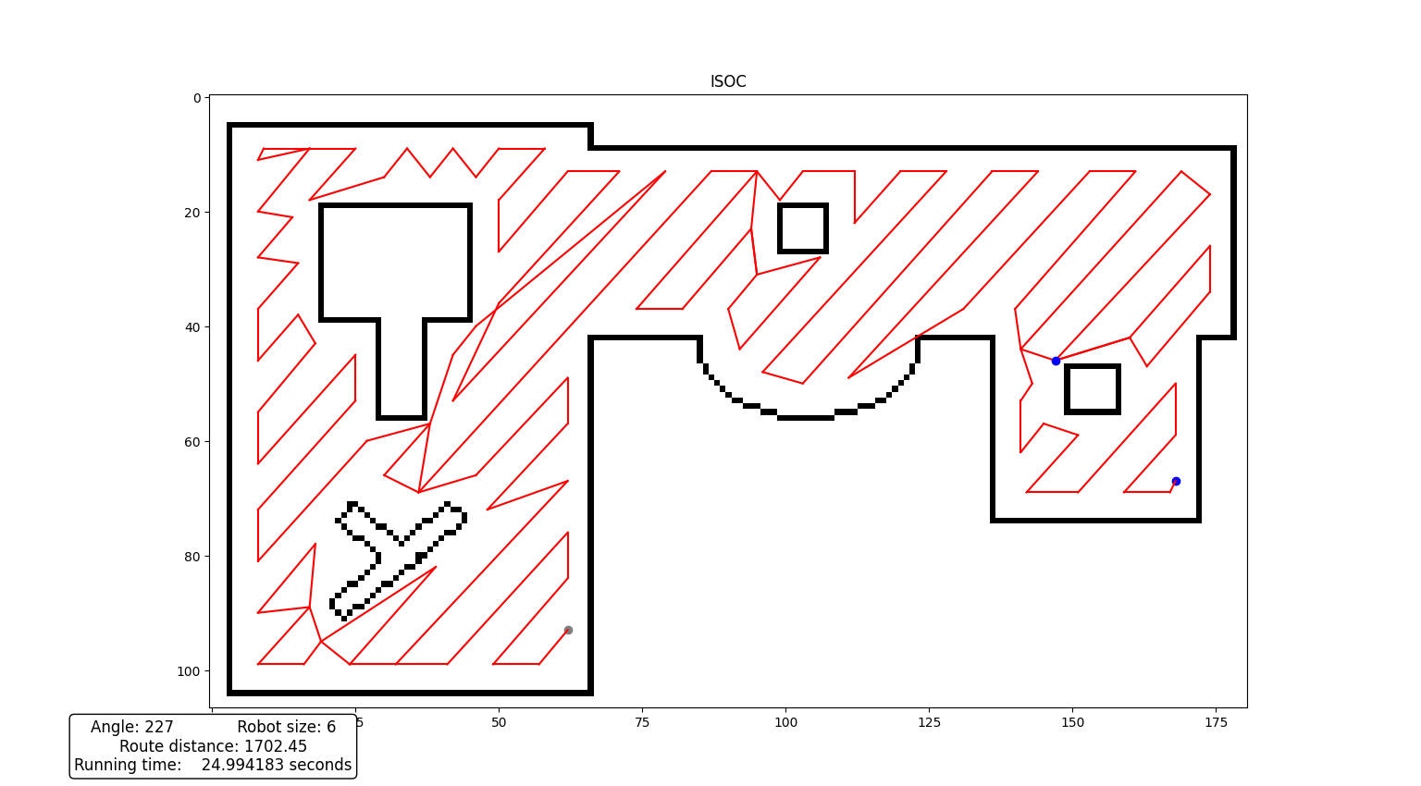
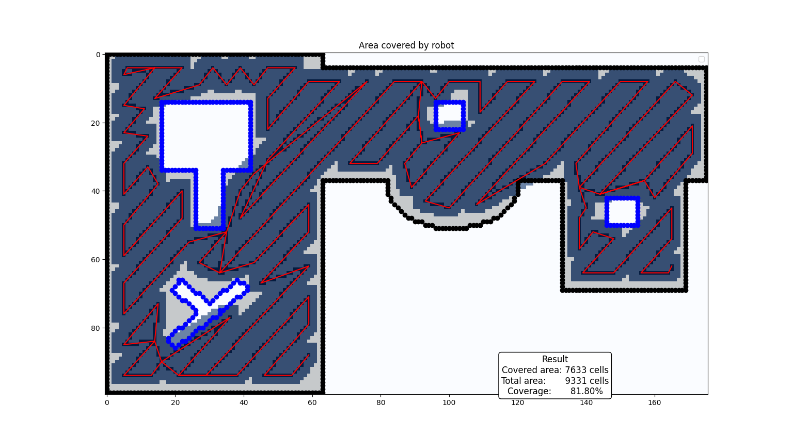


Best horizontal/vertical
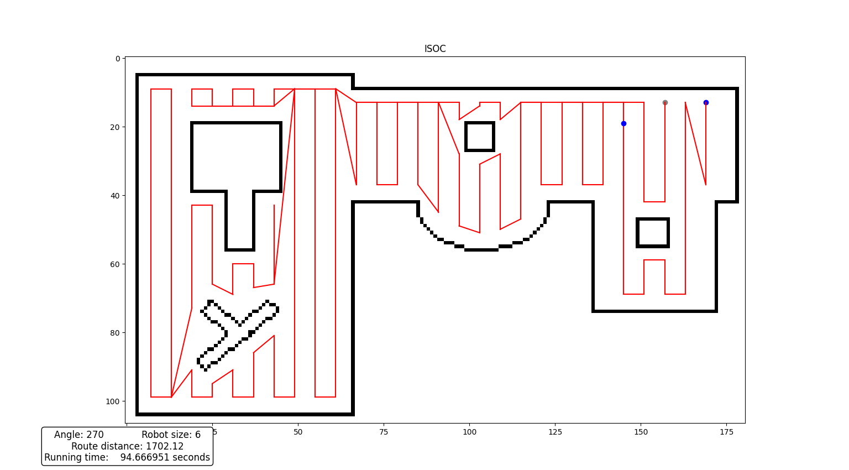
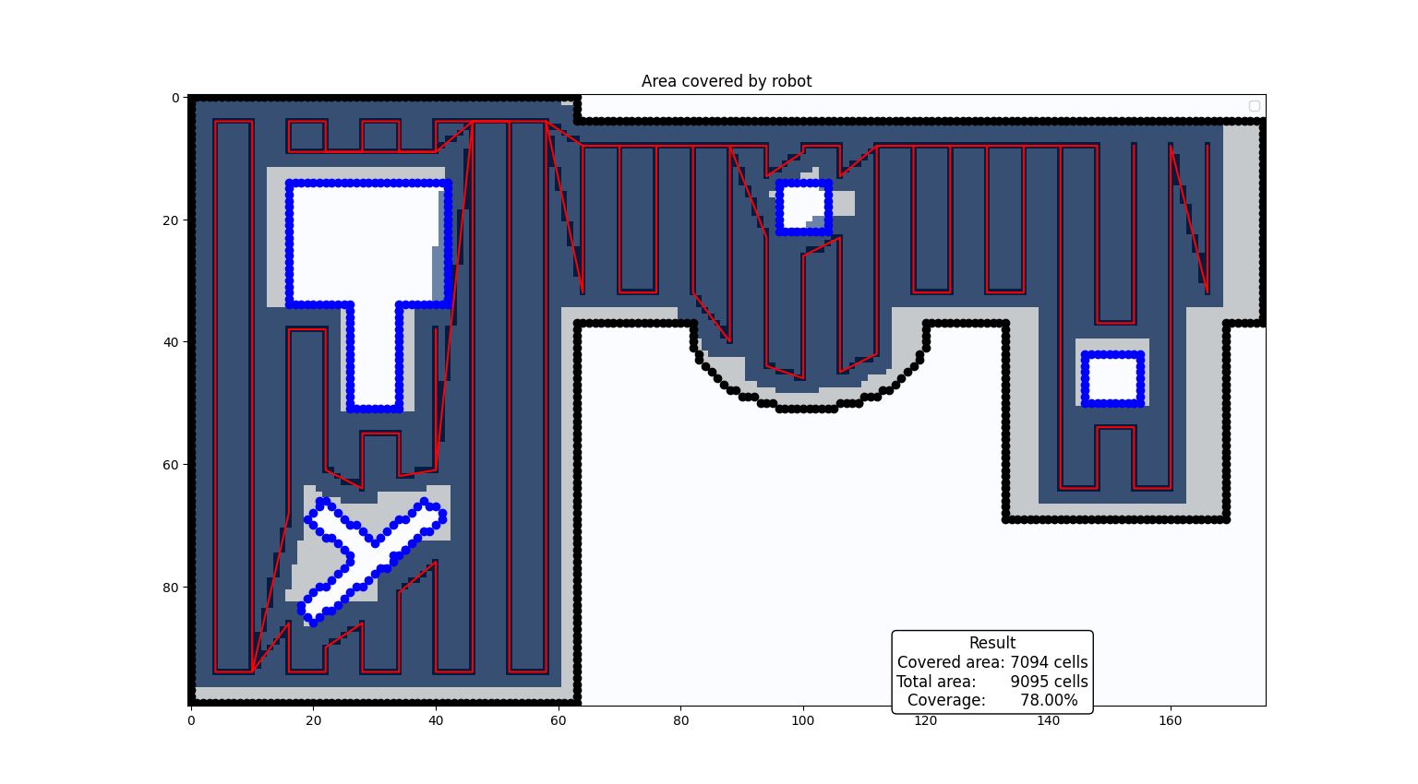

Best approximate vertical/horizontal angle degrees
